1. Generate 10 adversarial images (1 per class) from each dataset (i.e. MNIST, Fashion- MNIST and CIFAR-10 dataset) by using different attack techniques.

FGSM

It is to linearize the cost function used to train a model around the neighborhood of the training point. The resulting adversarial example corresponding to the input $x$ is computed as below:

$$x ←x+ ε∙∇ J(f, Θ, x)$$

* MNIST

The L2 distance is calculated by

$$d\left(Adv, Ori\right)=√[Σ{\left(Adv\left[:,:\right]-Ori\left[:,:\right]\right)]}^{2}$$

|  |  |
| --- | --- |
|  | L2 Distance:  58.638947 |
|  | 49.684406 |
|  | 53.834755 |
|  | 54.681152 |
|  | 52.770157 |
|  | 43.568077 |
|  | 56.02453 |
|  | 50.098133 |
|  | 53.93727 |
|  | 44.248154 |

* Fashion MNIST

|  |  |
| --- | --- |
|  | L2 Distance:  49.731827 |
|  | 52.33737 |
|  | 52.33743 |
|  | 57.61750 |
|  | 46.305008 |
|  | 49.135406 |
|  | 52.868507 |
|  | 58.084663 |
|  | 50.613808 |
|  | 58.124342 |

* Cifar10

|  |  |
| --- | --- |
|  | L2 Distance:  58.34123 |
|  | 60.342 |
|  | 70.34234 |
|  | 40.34237 |
|  | 70.59182 |
|  | 60.23486 |
|  | 65.45893 |
|  | 58.65934 |
|  | 50.83458 |
|  | 58.485 |

Basic Iterative Method

* MNIST

|  |  |
| --- | --- |
|  | L2 Distance:  68.2348 |
|  | 69.3845 |
|  | 65.2384 |
|  | 20.459 |
|  | 54.148 |
|  | 44.349 |
|  | 34.549 |
|  | 49.4859 |
|  | 45.48235 |
|  | 33.12348 |

* Fashion MNIST

|  |  |
| --- | --- |
|  | L2 Distance:  36.150993 |
|  | 35.113922 |
|  | 32.874474 |
|  |  |
|  | 38.022118 |
|  | 29.258118 |
|  | 40.22332 |
|  | 32.052715 |
|  | 32.017265 |
|  | 33.219147 |

* Cifar10

|  |  |
| --- | --- |
|  | L2 Distance:  67.3489 |
|  | 65.34823 |
|  | 79.3458 |
|  | 68.34588 |
|  | 78.3458 |
|  | 68.3412 |
|  | 54.2913 |
|  | 32.495 |
|  | 50.1923 |
|  | 60.4903 |

Momentum Iterative method

* MNIST

|  |  |
| --- | --- |
|  | L2 Distance:  58.638947 |
|  | 49.684406 |
|  | 53.834755 |
|  | 54.681152 |
|  | 52.770157 |
|  | 43.568077 |
|  | 56.02453 |
|  | 50.098133 |
|  | 53.93727 |
|  | 44.248154 |

* Fashion MNIST

|  |  |
| --- | --- |
|  | 41.135635 |
|  | 45.73863 |
|  | 38.48382 |
|  | 41.70452 |
|  | 32.59449 |
|  | 47.682644 |
|  | 38.61961 |
|  | 34.96115 |
|  | 44.893368 |
|  | 46.37036 |

* Cifar10

|  |  |
| --- | --- |
|  | 45.4934 |
|  | 74.4539 |
|  | 34.5965 |
|  | 56.23459 |
|  | 65.3459 |
|  | 70.3495 |
|  | 69.495 |
|  | 55.546 |
|  | 34.2341 |
|  | 54.895 |

Saliency Map Attack

* MNIST

|  |  |
| --- | --- |
|  | L2 Distance:  58.996033 |
|  | 14 |
|  | 13.958878 |
|  | 28.186512 |
|  | 22.35225 |
|  | 40.974213 |
|  | 19.889889 |
|  | 17.790482 |
|  | 68.6289 |
|  | 10.442184 |

* **Fashion Mnist**

|  |  |
| --- | --- |
|  | 12.42352 |
|  | 32.3413 |
|  | 6.2145 |
|  | 10.1593 |
|  | 32.3413 |
|  | 12.65923 |
|  | 5.3896 |
|  | 6.34893 |
|  | 13.1383 |
|  | 18.3478 |

* **Cifar10**

|  |  |
| --- | --- |
|  | L2 Distance:  3.293041 |
|  | 16.619839 |
|  | 4.5920796 |
|  | 6.6491357 |
|  | 20.610796 |
|  | 3.504764 |
|  | 10.67778 |
|  | 49.69607 |
|  | 2.267498 |
|  | 2.710019 |

Saliency Map attack is able to introduce a small perturbation to the original image and effectively makes the model misclassified the objects. It has the smallest L2 distance between the original image and the adversarial image, compared to FGSM, MIM, and BIM.

CW

* MNIST

|  |  |
| --- | --- |
|  | 9.5934 |
|  | 5.3996 |
|  | 6.348 |
|  | 10.3996 |
|  | 6.3492 |
|  | 4.650 |
|  | 9.6039 |
|  | 5.069 |
|  | 11.2954 |
|  | 10.294 |

* Fashion MNIST

|  |  |
| --- | --- |
|  | 15.395 |
|  | 6.3493 |
|  | 5.394 |
|  | 5.92 |
|  | 4.6923 |
|  | 6.392 |
|  | 10.954 |
|  | 6.943 |
|  | 6.1349 |
|  | 5.3920 |

From the figure above, the Carlini & Wagner L2 attack managed to make the classifier misclassified the object effectively by just introducing the smallest perturbation. The L2 distance between the adversarial image and the original image is relatively smaller compared to FGSM, BIM, MIM and SMA.

3) Analyze the result after applying a defense technique, namely adversarial training.

|  |  |  |  |
| --- | --- | --- | --- |
| Dataset | Attack Method | Test accuracy on adversarial example | Test accuracy on adversarial example after defense techniques |
| MNIST  MNIST  MNIST  FMNIST  FMNIST FMNIST CIFAR10  CIFAR10 | FGSM  BIM  MIM FGSM  BIM  MIM  FGSM  BIM | 0.1143  0.0059  0.0049  0.0631  0.0636  0.0643  0.1295  0.0734 | 0.2254  0.1493  0.1175  0.1498  0.0974  0.1179  0.6540  0.0994 |

The application of defense against the adversarial examples is to make the model smoother by limiting the sensitivity to small perturbation of its inputs. Three types of attack (FGSM, BIM, MIM) are used against the MNIST, FMNIST, CIFAR10 datasets respectively. As the table illustrated, we can see that the accuracies increased after the application of the defense techniques for each test sample. The results show that the adversarial technique is able to increase the effectiveness of the adversarial model, especially the FGSM(CIFAR10), the accuracies was increased to 0.6540 from 0.1295.

4) Perform and analyze between a white-box attack and a black-box attack by using Basic Iterative Method attack technique.

White Box Attack:

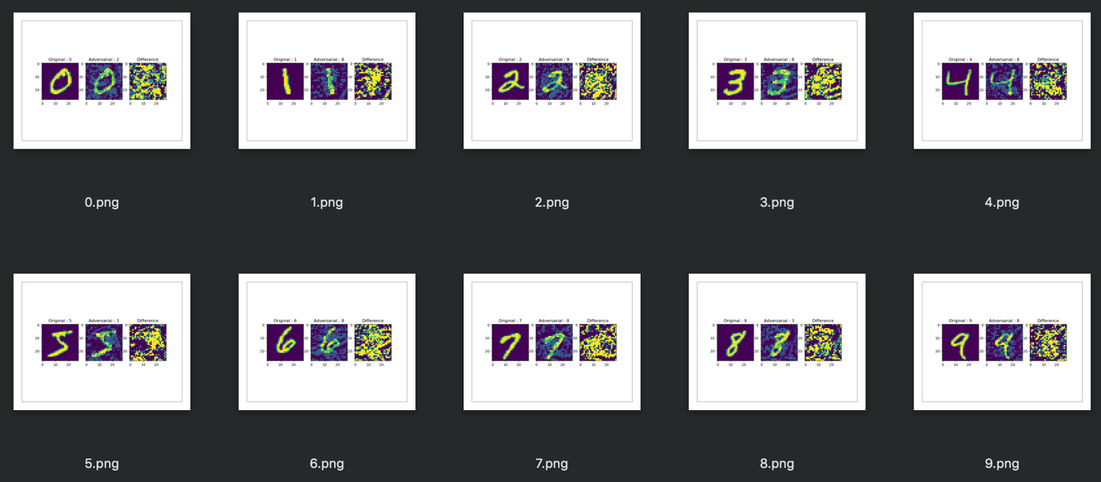

Black Box Attack:



Black box trains a local model to substitute for the target DNN, using the inputs synthetically generated by an adversary and labeled by the target DNN. As black box suggested, it has no information about the structure or parameters of the DNN, and also does not have access to any large training dataset. It can only observe labels assigned by the designated model for chosen inputs. It segregates and trains a local substitute with a synthetic dataset – the inputs are synthetic and generated by the adversary while the outputs are the labels assigned by the target DNN and observed by the adversary. Black box strategy is to learn the substitute for the target model using a synthetic dataset generated by the adversary and labeled by observing the oracle output. Then, the adversarial examples are crafted using this substitute. We can see that the target DNN misclassified them due to the transferability between architecture.

For the white box attack, the intruder has the access to the model’s parameters while the black box attacks the intruder has zero access to these parameters. It uses different model to generate adversarial images and run against the target model.

The results show that the white box attack using the basic iterative method achieves better results on the adversary, and also outperforms the ones with black box attack. The performance in black box attacks declined along with the number of epochs in the basic iterative method.

The dataset that I have targeted on was MNIST dataset, with the Basic Iterative Method.

As shown in the figure above, the labeling between the input and the adversary does not make a significant mismatch on the accuracies in the black box attack. Whereas, in the white box attack, it has introduced adversarial noises which managed to fool the classifier to make the model misclassified label. In summary, the adversarial examples that generated by white box attack method are much tractable than the black box attack.